Team 5 – ICT Project 2

**Reliance Fresh grocery store**



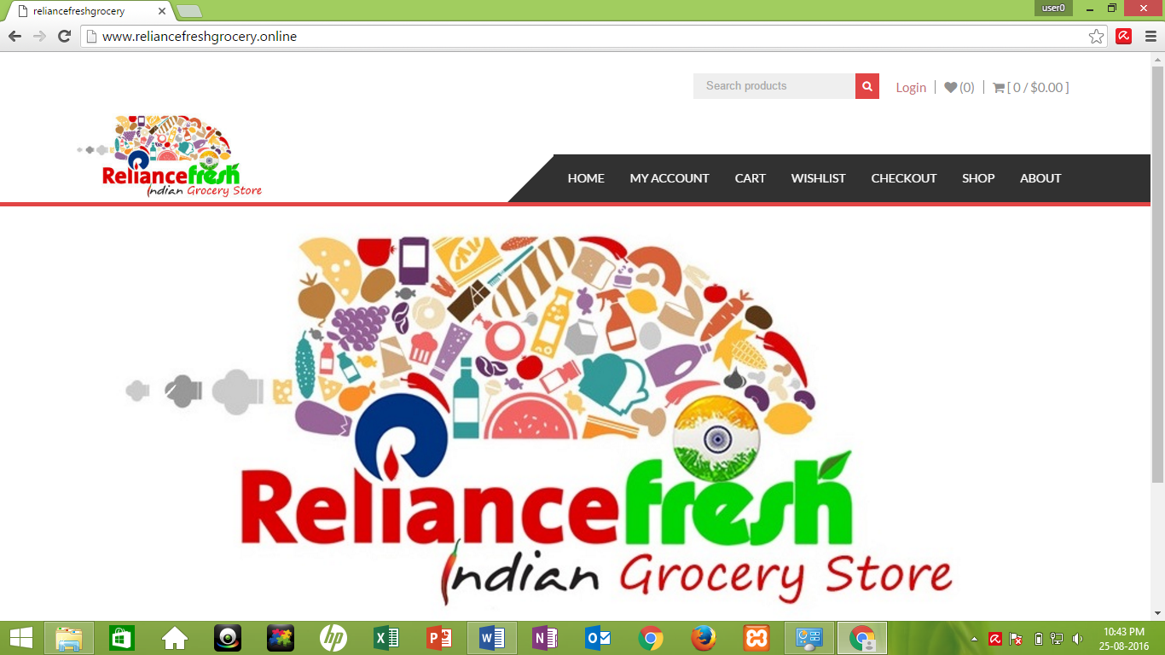

Submitted by: Team 5

Submitted to: Laura Antochi

Due date: 26th Aug 2016

Submission date: 26th Aug 2016

1. INTRODUCTION TO TEAM-5

This project involves a team of two members with their separate role and responsibilities of design, implementation and analysis.

Following are the details of the team members:

|  |  |
| --- | --- |
| **Name** | **Student ID** |
| Anay Gharat | 13131701 |
| Gagandeep Singh | 13126300 |

Roles and responsibilities of team members are listed in the following table:

|  |  |
| --- | --- |
| **Name** | **Roles & Responsibilities** |
| Anay Gharat | * User interface design * Meeting arrangement with client * Gather requirements from client * Selecting suitable theme & templates for website * Licence agreement with client |
| Gagandeep Singh | * Project documentation * User interface design * Database making and connectivity * Site layout |

1. BETA AND FINAL RELEASE DELIVERABLES

|  |  |
| --- | --- |
| **BETA RELEASE** | **FINAL RELEASE** |
| Wish list option added | Social Media Live Feeds |
| New theme selection | Google Analytics |
| Registration page upgraded | SEO |
| Website’s Logo upgraded | Bug Fixes |
| Search products button | Testing |

Following are the Screenshots of our Website upgradations which we made during BETA release as per Client and Lecturer’s advice:

1. **New theme selection:**

As our lecturer was not much happy about the theme we selected because it was not appealing, so we have changed the theme of our website. We added slide pictures of the products of store through which visitors can easily get attracted to the website and start browsing it.

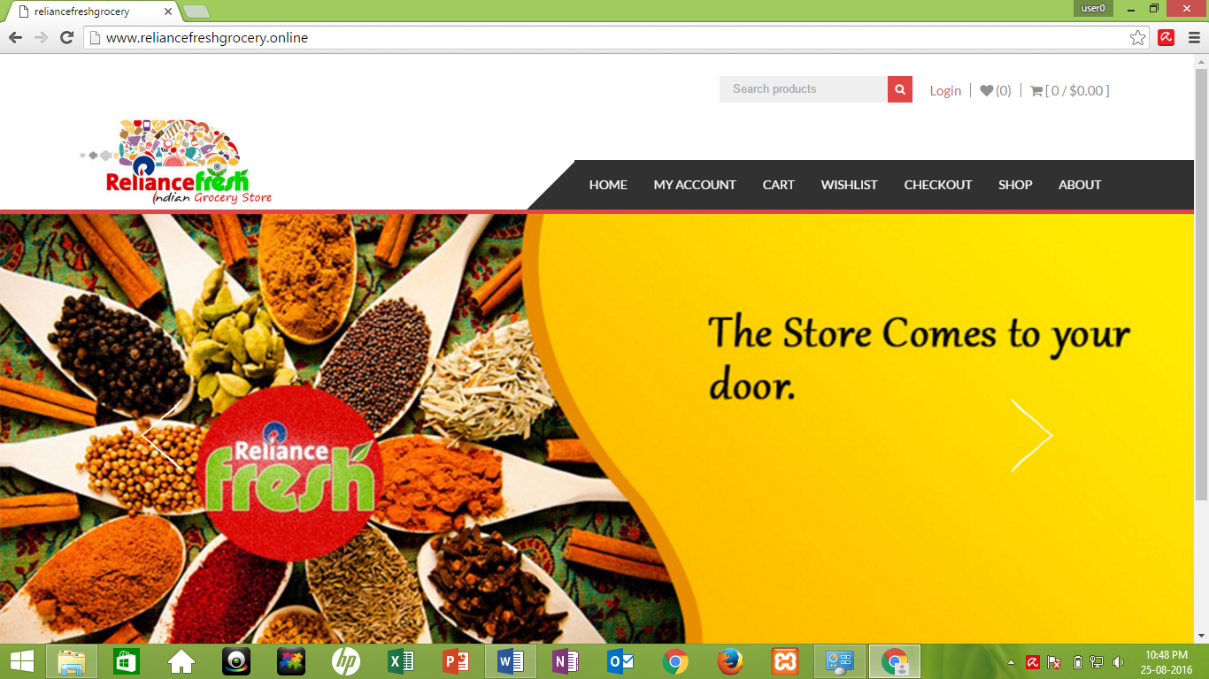

Fig: Homepage with new theme along with sliding pictures

1. **Registration Page**

In alpha release, it was mandatory to register on website for any purchase and there were some personal questions asked for registering. But now in Beta release we have made some changes for registering people onto website. During checkout when buyer will enter the billing details with his email ID, he can select the check option whether he want to register or not. If he selects to register, a welcome email will be sent to his email address.

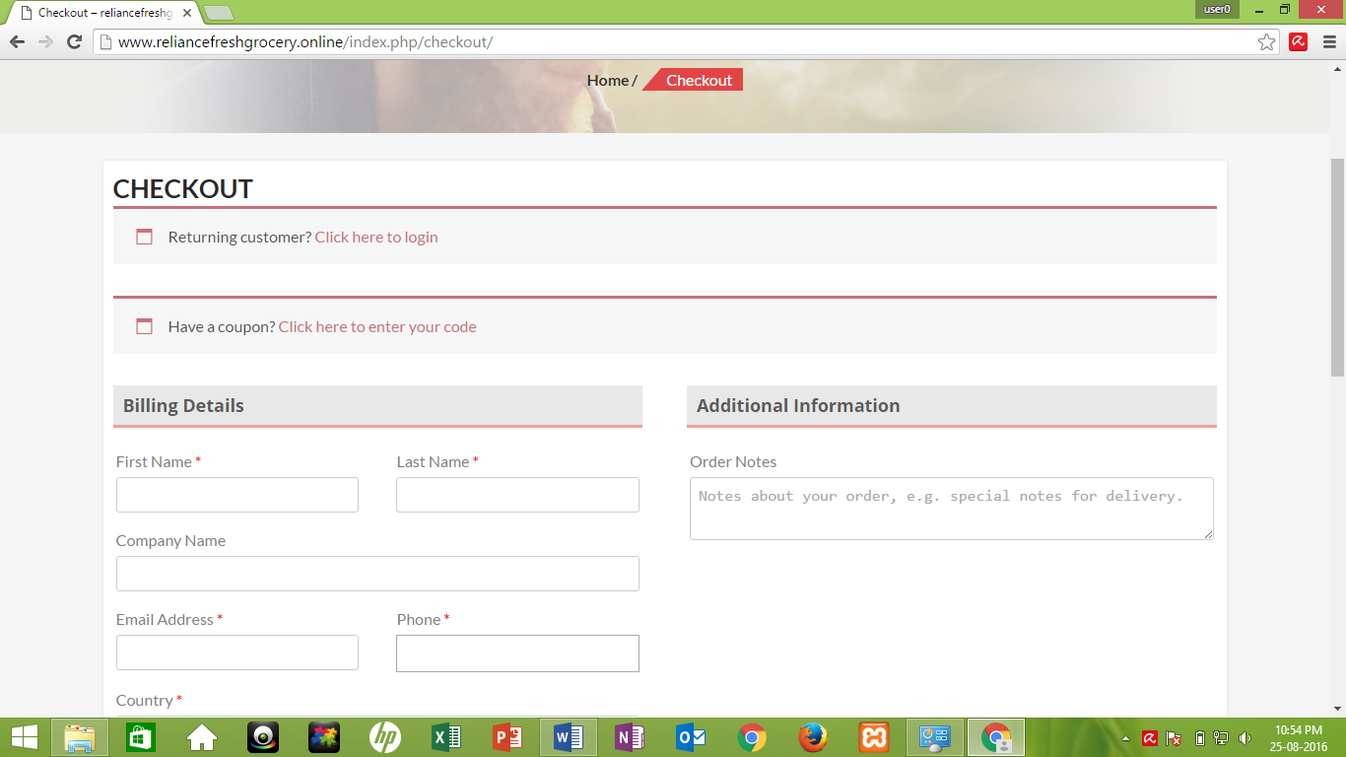

Fig: Registration cum check out page

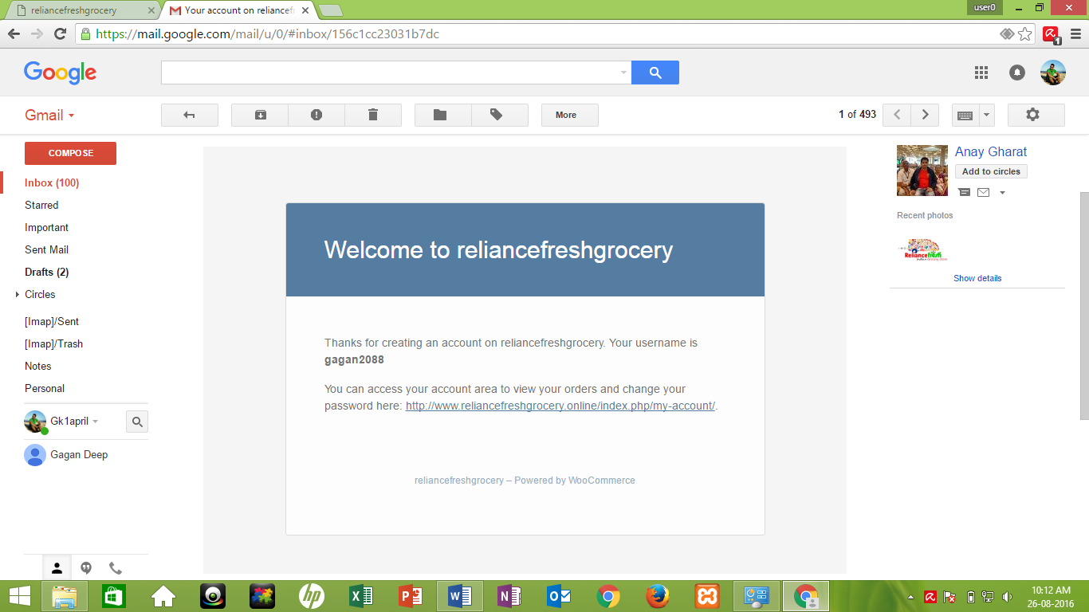

Fig: Welcome mail sent to the registered user

1. **Wish list Page**

New page has been added into website named “Wish list” in which all the items liked by the user will be added into wish list. After, he can select any items from his favourite list to buy.

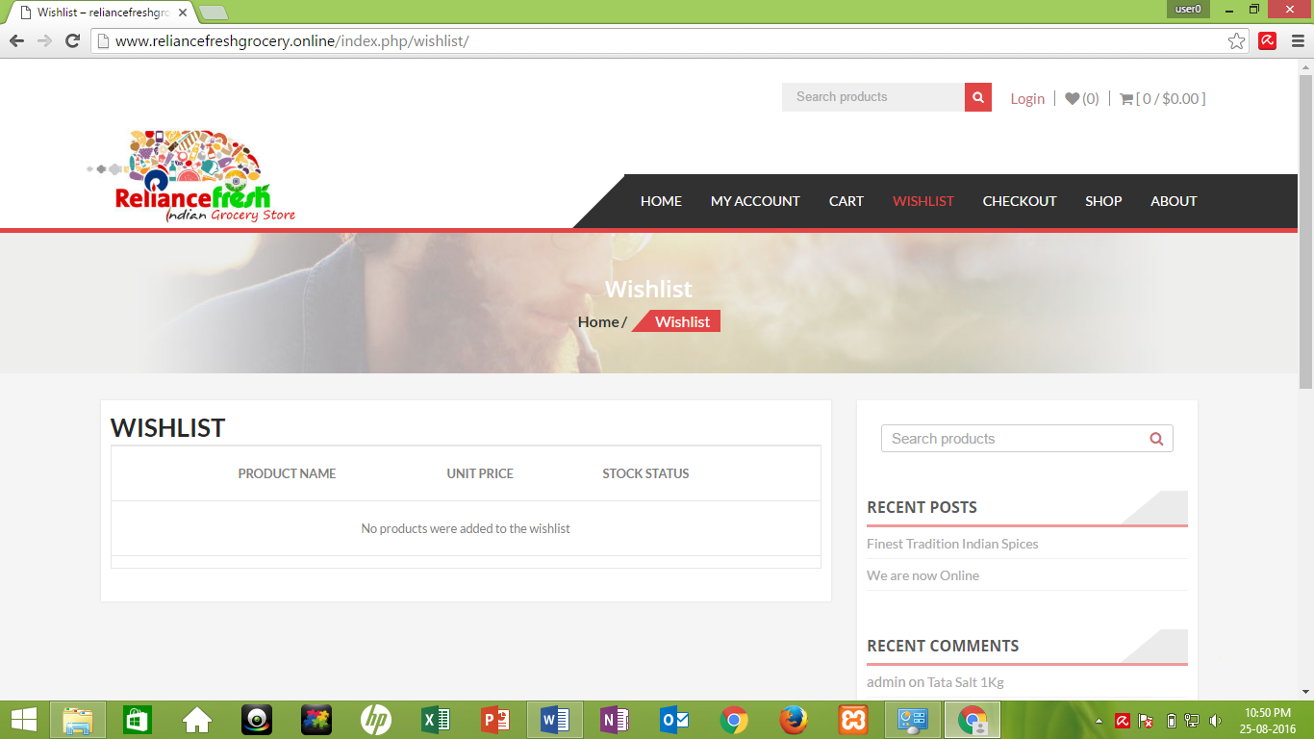

Fig: Wish list page

1. **Search Products**

Search engine option has been updated on the top of the website for search of any products available at the store.

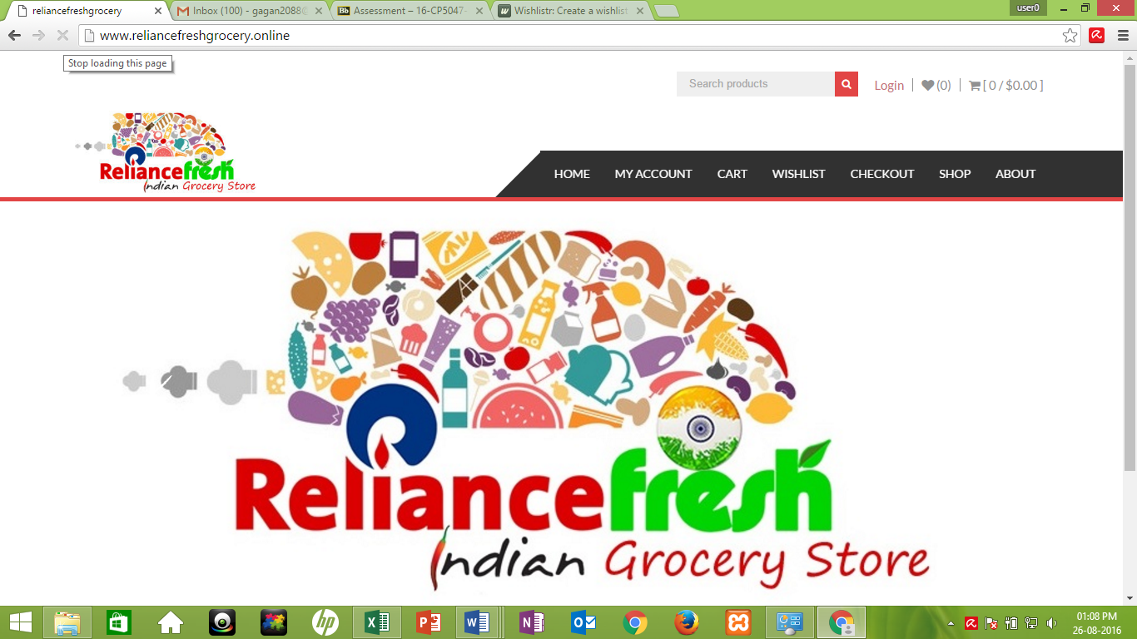

Fig: Arrow in the fig shows the Search Products facility

1. User Stories log for Alpha and Beta Release with Velocity



1. Client Signed Acceptance of BETA Release and the Proposed FINAL Release

